**Function**

A function is a block of organized, reusable code that is used to perform a single, related action. Functions provide better modularity for your application and a high degree of code reusing.

As you already know, Python gives you many built-in functions like print(), etc. but you can also create your own functions. These functions are called *user-defined functions.*

## Syntax

def functionname( parameters ):

"function_docstring"

function_suite

return [expression]

def printme( str ):

"This prints a passed string into this function"

print str

return

Once the basic structure of a function is finalized, you can execute it by calling it from another function or directly from the Python prompt.

# Function definition is here

def printme( str ):

"This prints a passed string into this function"

print str

return;

# Now you can call printme function

printme("I'm first call to user defined function!")

printme("Again second call to the same function")

# 

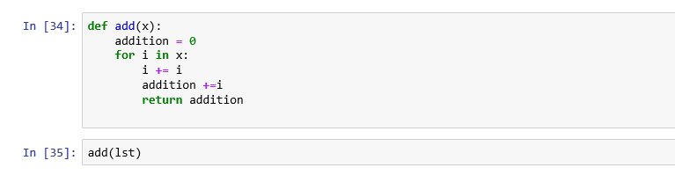

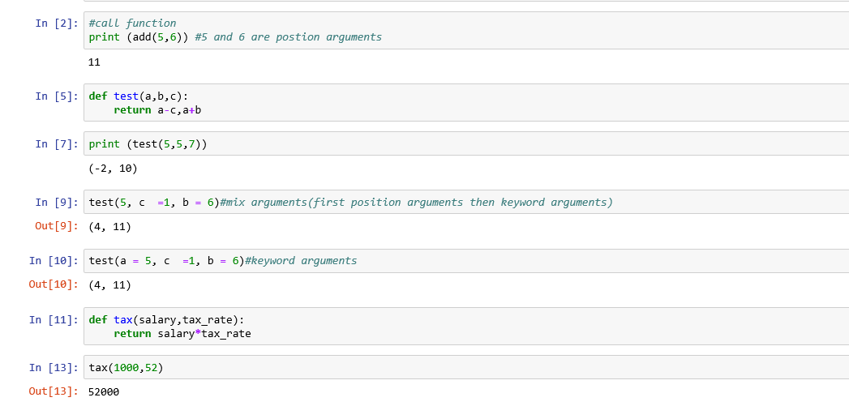

**Dictionary**

Each key is separated from its value by a colon (:), the items are separated by commas, and the whole thing is enclosed in curly braces. An empty dictionary without any items is written with just two curly braces, like this: {}.

Keys are unique within a dictionary while values may not be. The values of a dictionary can be of any type, but the keys must be of an immutable data type such as strings, numbers, or tuples.

## Accessing Values in Dictionary

To access dictionary elements, you can use the familiar square brackets along with the key to obtain its value. Following is a simple example –

dict = {'Name': 'Zara', 'Age': 7, 'Class': 'First'}

print "dict['Name']: ", dict['Name']

print "dict['Age']: ", dict['Age']

When the above code is executed, it produces the following result −

dict['Name']: Zara

dict['Age']: 7

If we attempt to access a data item with a key, which is not part of the dictionary, we get an error as follows –

dict = {'Name': 'Zara', 'Age': 7, 'Class': 'First'}

print "dict['Alice']: ", dict['Alice']

When the above code is executed, it produces the following result −

dict['Alice']:

Traceback (most recent call last):

File "test.py", line 4, in <module>

print "dict['Alice']: ", dict['Alice'];

KeyError: 'Alice'

## Updating Dictionary:

You can update a dictionary by adding a new entry or a key-value pair, modifying an existing entry, or deleting an existing entry as shown below in the simple example –

dict = {'Name': 'Zara', 'Age': 7, 'Class': 'First'}

dict['Age'] = 8; # update existing entry

dict['School'] = "DPS School"; # Add new entry

print "dict['Age']: ", dict['Age']

print "dict['School']: ", dict['School']

When the above code is executed, it produces the following result –

dict['Age']: 8

dict['School']: DPS School

## Delete Dictionary Elements

You can either remove individual dictionary elements or clear the entire contents of a dictionary. You can also delete entire dictionary in a single operation.

To explicitly remove an entire dictionary, just use the **del** statement. Following is a simple example –

dict = {'Name': 'Zara', 'Age': 7, 'Class': 'First'}

del dict['Name']; # remove entry with key 'Name'

dict.clear(); # remove all entries in dict

del dict ; # delete entire dictionary

print "dict['Age']: ", dict['Age']

print "dict['School']: ", dict['School']

This produces the following result. Note that an exception is raised because after **del dict** dictionary does not exist any more −

dict['Age']:

Traceback (most recent call last):

File "test.py", line 8, in <module>

print "dict['Age']: ", dict['Age'];

TypeError: 'type' object is unsubscriptable

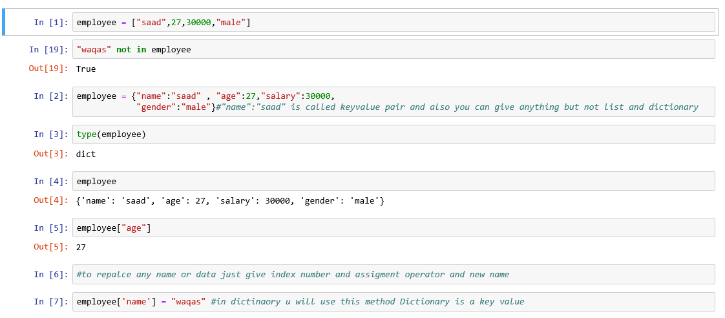

**Task:** Using dictionary make different data sets.

**TASK:** Make a function of importing csv files.